Chapter 19, Solution 14.

To find 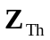, consider the circuit in Fig. (a).

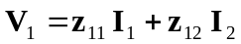 (1)
V_{o} = 1
+
−
(a)
+
V₁
−
I₁
I₂
Z_{S}
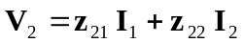 (2)

But
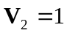, 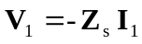

Hence, 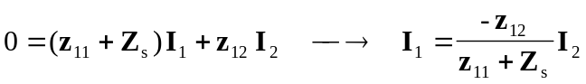
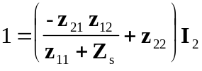

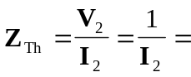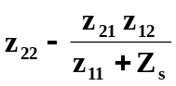

To find 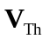, consider the circuit in Fig. (b).
(b)
+
V₁
−
I₁
V_{S}
+
V₂ = V_{Th}
−
Z_{S}
I₂ = 0
+
−

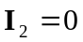, 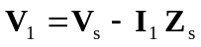

Substituting these into (1) and (2),
